**Защита лабораторной работы**

Листинг программы

using System;

using System.Collections.Generic;

using System.ComponentModel;

using System.Data;

using System.Drawing;

using System.Linq;

using System.Text;

using System.Threading.Tasks;

using System.Windows.Forms;

namespace WindowsFormsApp3

{

public partial class Form1 : Form

{

public Form1()

{

InitializeComponent();

}

private void pictureBox1_MouseMove(object sender, MouseEventArgs e)

{

if (e.Button == MouseButtons.Left)

{

Pen blackPen = new Pen(colorDialog1.Color, 1);

// Рисовать так:

Graphics g = Graphics.FromImage(pictureBox1.Image);

int CursorX = e.X;

int CursorY = e.Y;

Point point = new Point(CursorX, CursorY);

Point previousPoint = new Point(CursorX - 1, CursorY - 1);

g.DrawLine(blackPen, previousPoint, point);

blackPen.Dispose();

g.Dispose();

pictureBox1.Invalidate();

}

}

private void pictureBox1_MouseDown(object sender, MouseEventArgs e)

{

}

private void сменитьЦветToolStripMenuItem_Click(object sender, EventArgs e)

{

if (colorDialog1.ShowDialog() == DialogResult.OK)

{

}

}

private void сохранитьToolStripMenuItem_Click(object sender, EventArgs e)

{

if (saveFileDialog1.ShowDialog() == DialogResult.OK)

{

Bitmap bmp = new Bitmap(pictureBox1.Image);

bmp.Save(saveFileDialog1.FileName, System.Drawing.Imaging.ImageFormat.Bmp);

}

}

private void открытьToolStripMenuItem_Click(object sender, EventArgs e)

{

if (openFileDialog1.ShowDialog() == DialogResult.OK)

{

Image image = Image.FromFile(openFileDialog1.FileName);

int width = image.Width;

int height = image.Height;

pictureBox1.Width = width;

pictureBox1.Height = height;

Bitmap bmp = new Bitmap(Image.FromFile(openFileDialog1.FileName), width, height);

pictureBox1.Image = bmp;

}

}

private void очиститьToolStripMenuItem_Click(object sender, EventArgs e)

{

Bitmap b = new Bitmap(pictureBox1.Width, pictureBox1.Height);

using (Graphics g = Graphics.FromImage(b))

{

g.Clear(Color.White);

}

pictureBox1.Image = b;

openFileDialog1.FileName = "";

}

private void выйтиToolStripMenuItem_Click(object sender, EventArgs e)

{

this.Close();

}

private void Form1_Resize(object sender, EventArgs e)

{

if (openFileDialog1.FileName == "")

{

Bitmap b = new Bitmap(this.Width, this.Height);

using (Graphics g = Graphics.FromImage(b))

{

g.Clear(Color.White);

}

pictureBox1.Image = b;

}

pictureBox1.Width = this.Width;

pictureBox1.Height = this.Height;

}

}

}

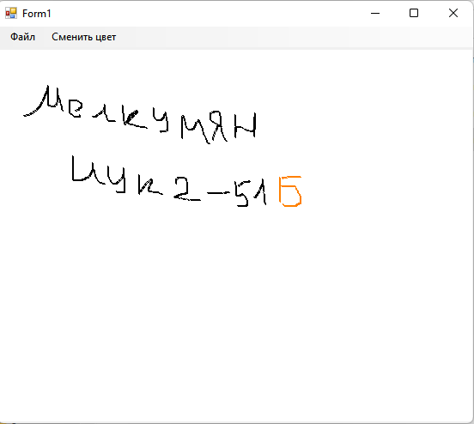

**Рис 1. Результат выполнения программы**

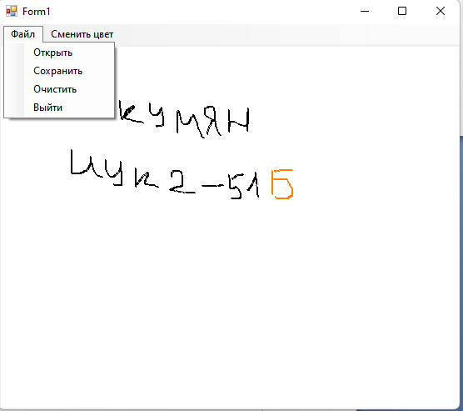

**Рис 2. Результат выполнения программы 2**

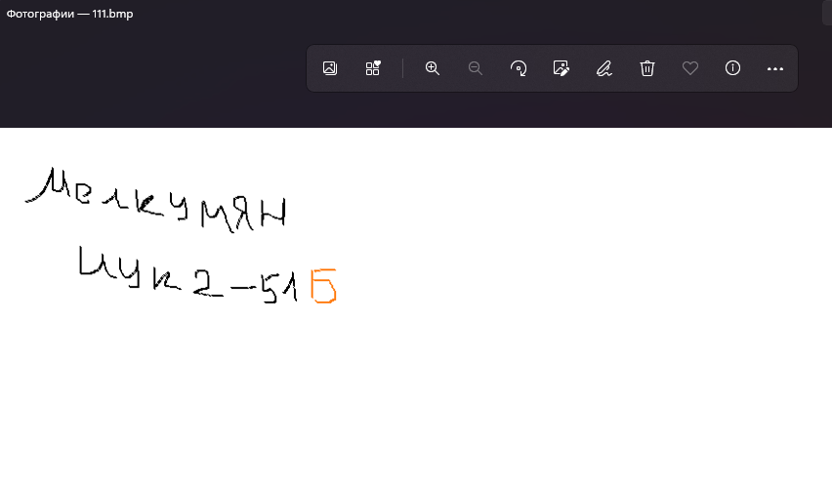

**Рис 3. Результат сохранения изображения**